

|  |
| --- |
| E-KATALOG PROMOSI USAHA NELAYAN  text divider |
| Versi: 1.0.0  Halaman: [jumlah halaman]  Status: on going  Confidentiality: Publik |
| TEKNIK INFORMATIKA POLITEKNIK NEGERI BATAM  Disusun oleh: PBL IF-41 |
|  |

# Project Identity

# Tabel 1. Project identity

|  |  |  |
| --- | --- | --- |
| Nomor ID | : | *41* |
| Project Proponent | : | Ahmad Hamim Thohari, S.S.T., M.T |
| Project Manager | : | Muchamad Fajri Amirul Nasrullah, S.ST.,Sc |
| Co Manpro | : | - |
| Project Title | : | *E-Katolog Promosi Usaha Nelayan* |
| Outputs | : | *Application Product, IPR, Scientific Article, Final Report, Demo Video, Poster, Manual Book* |
| Client/Customer | : | Muchamad Fajri Amirul Nasrullah, S.ST.,Sc |
| Steering Committee (Lecturer & Laboran of PBL course) | : | 1. Muchamad Fajri Amirul Nasrullah, S.ST.,Sc [ Mobile] 2. Athailah.S.Kom [ Proyek Inovasi Agile] 3. Rina Yulius, S.Pd., M.Eng [ Interaksi Manusia Komputer ] 4. Satriya Bayu Aji, S.S., M.Hum. [ Bahasa Inggris Untuk Komunikasi ] 5. Dodi Prima Resda, S.Pd., M.Kom [ Jaringan Komputer ] 6. Riwinoto, ST,M.Kom [ Rekayasa Perangkat Lunak Lanjut] 7. Arif Roziqin,S,Pd,M.Sc[Pendidikan Pancasila] 8. Farouki Dinda Rassanrandi ,S.T,M[Pendidikan Kewarganegaraan] |
| Anggota Tim Mahasiswa | : | 1. 3312201012– Sariana Parnauli Tamba[Ketua] 2. 3312211010– Kenzi Basmaniyahya Putra Panji 3. 3312211013– Adista azzahra 4. 3312211015–Bagus Prasetyo 5. 3312211016 –Irwanda Andika Putra |

Daftar Isi

Identitas Proyek 3

Daftar Isi 5

Riwayat Dokumen 6

Daftar Gambar 7

Daftar Tabel 9

Daftar Lampiran 10

Riwayat Pengerjaan Proyek 11

Spesifikasi Sistem 15

A. Deskripsi Umum 15

B. User Stories 15

C. Prioritized Requirement List 16

D. Pemodelan Sistem 16

E. Desain Basisdata 24

F. Desain Antarmuka Error! Bookmark not defined.

Hasil Implementasi 42

A. Implementasi Aplikasi 42

B. Implementasi Basis Data 42

C. Pengujian Aplikasi dan Deployment 42

Penutup 43

Kesimpulan 43

Lesson Learned 43

LAMPIRAN 44

# Daftar Gambar

Gambar 1. General description .............………………………………………………………….........................………..14

Gambar 2. Use Case Diagram ………….…………………………………………….....................................................17

Gambar 3. . Sequence Diagram.....……………………….…………………….........................…..............................18

Gambar 4. Activity Diagrams of Product List View……………………………………….........................…………… 19

Gambar 5. Activity Diagram of Buying a product………………………….......................................................20

Gambar 6. ERD Diagram................................……..........……………………………………………..........................21

Gambar 7. Skema Rasional .................………………………………………………………….…………………………….......22

Gambar 8. Wireframe Fisherman Business Promotion E-Catalog ……………………………………………….......23

Gambar 9. Implementasi Home & Category Implementation Image…………………………………………………24

Gambar 10. Implementasi Product page and product detail images………........………….........................25

Gambar 11. Implementasi Send Whatsapp.......................... ...........…………………........................………..25

Gambar 12. .Image of E-KPUN database implementation results……………………………………………………..26

# Daftar Tabel

Tabel 1. Identitas Proyek...………………………………………………………………………………...............................3

Tabel 2. Workmanship History.…..………………………………………………………………………….........................7

Tabel 3. Application Version History……………………………………………………………………...........................7

Tabel 4. Group member contribution………………………………………………...............................................8

Tabel 5. Communication with Client/Project Proponent.……………………………………………………...........9

Tabel 6. Funcional Requirement.......……………………………………………...……..........................................12

Tabel 7. Non Funcional Requirement........……………………………………………………………………………….......12

Tabel 8. Usecase Scenario Viewing Products.....…………………………………………………………………….........15

Tabel 9. Usecase Scenario 2 Buying a Product …………………………………………………………………………......16

Tabel 10. Activity Diagaram Mengisi Formulir……………………………………………………………………….........18

Tabel 11. Activity Diagram Admin Mengelola Informasi PPID……...……………………………………….........19

Tabel 12. Activity Diagram Admin Mengelola Permohonan PPID…… …………………………………….........20

Tabel 13. Activity Diagram Admin Mengelola Menu PPID.…………………………………………………….........21

Tabel 14. Activity Diagram melihat Informasi......………………………………………………………………….........22

Tabel x…….......…………………………………………………………………………........................................................

Tabel x…….......…………………………………………………………………………......................................................

* Project Work History

Output Work History

Tabel 2. Workmanship History

|  |  |  |
| --- | --- | --- |
| Task | Completion Date | Outcome. |
| Planning | August 29, 2023 | * Making Rpp, as well as the first meeting with manpro |
| Analysis | September 15, 2023 | * General Description * User Analysis * User story (FR & NFR) * Questionnaire for Application needs |
| Design | September 20, 2023 | * Wireframe * Mock Up * ERD * Relationship schema |
| Implementation | December 15, 2023 | * Frond end back end |
| Testing | December 20, 2023 | - |

Application Version History

Tabel 3. Application Version History

|  |  |  |
| --- | --- | --- |
| Versi | Tanggal Rilis | Detail Versi |
| 1.0 | September 25, 2023 | Initial version, Home Page |
| 1.1 | October 10,2023 | Addition of product list feature, product code |
| 1.2 | October 25, 2023 | Addition of description feature, How to Buy |
| 1.3 | October 5, 2023 | Addition of seller contacts |

* Tabel 4. Group member contribution

|  |  |  |
| --- | --- | --- |
| Member Name | Contribution | Outputs produced |
| Sariana Parnauli Tamba | * Scheduling * Make a design * Documentation | * Report * ERD * Usecase Scenario * Relational Model |
| Kenzi Basmaniyahya | * Documentation * Deign * Documentation | * Riport * Ppt * ERD * Wireframe |
| Bagus Prasetyo | * Design * Documentation | * Wireframe * Mockup * Relationship scheme * ppt |
| Irwanda | * Design * Documentation | * App page design * Relationship scheme * Frond end back end |
| Adista | * Documentation, analysis | * Laporan * Analisis fungsional, kebutuhan dan non fungsional |

Communication History with Client/Proposer

Tabel 5. Communication with Client/Project Proponent

|  |  |  |  |
| --- | --- | --- | --- |
| Date | Client Name | Media | Discussion |
| 25/08/2023 | Mr.M.Fajri Amirul N | Zoom  WhatsApp | * Discussion of Application Specifications, and Application Design, as well as explaining the form of application to be built |
| 20/10/2023 | Mr.M.Fajri Amirul N | Live Meeting | * Confirmation of application specifications |
| 13/12/2023 | Mr.M.Fajri Amirul N | Zoom  whatsApp | * Presentation of UTS report results * Asked for suggestions on what parts of the application should be improved. |
|  | Mr.M.Fajri Amirul N | Live meeting | * Confirmation of Application Progress |
|  |  |  |  |

|  |  |
| --- | --- |
|  |  |
|  |  |

Figure 1.Communication with Client/Project Proponent

# Spesifikasi Sistem

## General Description

## The Fishermen's Business Promotion E-Catologue is a digital platform used by fishermen to promote their seafood products to potential buyers or business partners. This platform aims to help fishermen to increase the vasibility and accessibility of their products in the market. E-Catologue of Fisherman Business Promotion is an application or website that presents complete information about seafood products produced by certain fishermen or fishermen groups. In this catologue, each product is equipped with descriptions, images, prices, and other related information. The aim is that by using this platform, fishermen can reach a wider market and reach wider and reach potential buyers in various regions, and encourage consumers to buy local products and support local fishermen's businesses and provide clear information about products and their origins so that consumers can make more informed decisions.

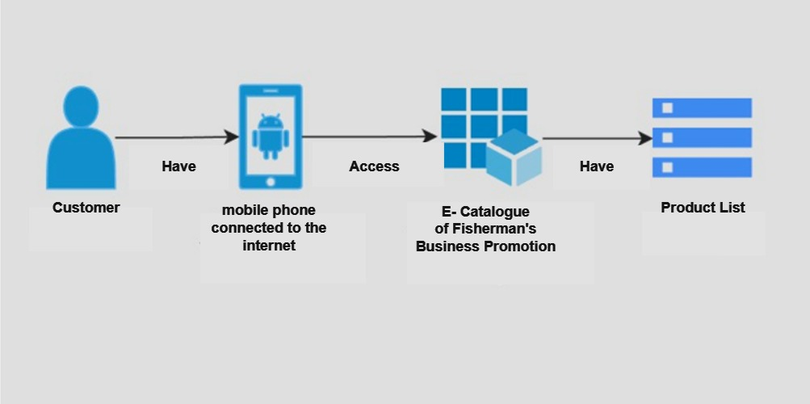

Figure 2.Overview of E-Catalog of Fishermen Business Promotion

The picture above illustrates that customers must have a mobile phone connected to the internet in order to access the Fisherman Business Promotion E-Catalog application which has a list of products that customers will buy.

## User Stories

Fungctional Requirement

Functional requirements are needs that contain a series of stages that the system can perform in the application. The FR also contains related information - information on the application system.

Tabel 6. Funcional Requirement

|  |  |  |
| --- | --- | --- |
| Functional Requirement | | |
| Customer | [FR-01]  [FR-02]  [FR-03] | * Customers can access the Fishermen's Business Promotion E-Catologue * Customers can see the main page and the contents of the products in the E-Catalog of Fisherman Business Promotion * Customers can purchase products that have been provided, and contact the available contacts to ask for product clarity. |

## Non Functional Requirment

Non-functional needs are needs that are needed by the system in running the product optimally. Needs are used to signify the feasibility of the condition of a system.

Tabel 7. Non Funcional Requirement

|  |
| --- |
| Non Functional Requirement |
| * E-Catologue of Fisherman Business Promotion in mobile form * Has an attractive UI/UX * Have good performance and able to handle high traffic from customers * Able to handle customer requests and provide responses that are responsive and understandable to customers. * Fisherman Business Promotion E-Catologue has a good level of security * E-Catologue of Fishermen's Business can be accessed using the internet |

## Pemodelan Sistem

1. User Identification

* The name of the application that will be built is the Nelaya Business Promotion E Catalog Application.
* Users of the Fisherman Business Promotion E-Catalog Application are fishermen who have a business and the general public

1. Questionnaire/Interview Guideline/Field observation form for the needs analysis process

* A questionnaire is a tool used to collect data or information from respondents in a study or survey. The questionnaire contains a series of questions designed to collect responses or opinions of respondents related to certain research.

respondents' opinions related to certain research

|  |
| --- |
| Introduction and Instructions |
| FISHERMEN BUSINESS PROMOTION E-CATALOG QUESTIONNAIRE  Dear Respondents  This questionnaire aims to find out user references in using the Fisherman's Business Promotion E-Catalog. This questionnaire aims to collect information related to the needs, specifications, modeling, analysis, and determination of the appearance that we will make.  In the midst of your busy schedule, please allow us to ask for your willingness to fill out a user research questionnaire containing a list of questions / statements related to Fisherman's Business.  The criteria for respondents in this user research are   * At least 17 years old * Batam State Polytechnic student   If you feel that you fit the criteria above, then with all humility we ask for your willingness and time to participate in this research. We need to say that in filling out this questionnaire, we will fully protect the confidentiality of your identity. Thank you for your attention and cooperation.  Procedure for filling out the questionnaire   * Fill in your name, department, study program, class, NIM, and age completely and correctly. * Answer each question honestly or according to your experience. * Choose the most appropriate answer * Provide suggestions if any |

|  |  |  |
| --- | --- | --- |
| Respondent Identification | | |
| Name : | | |
| Major : | | |
| Program Study : | | |
| Class : | | |
| Nim : | | |
| Usia : | | |
| 1 | Did you previously know or hear about fishing businesses? | * Yes Ever * Never |
| 2 | What do you know about fishermen? | - |
| 3 | What products do you want to be included in the fishermen business promotion e-catalog application? | * Marine Catches * Fish management and preservation * o Fish, shrimp, etc. seedlings * o Tourism cruises such as fishing and diving * o Other |
| 4 | What type of promotion do you think is most effective for fishing businesses? | * Social Media (Facebook, Instagram, etc.) * Banners or billboards * o Brochures or pamphlets * o Special offers or discounts * o Others. |
| 5 | Do you have any additional suggestions or input on what features should be included in the Fisherman Business Promotion E-Catalog application? | - |
| 6 | What are your suggestions or expectations for the Fisherman Business Promotion E-Catalog Application? | - |

3.Use Case

Use cases are one of the concepts in software engineering used to detail and understand how a system will be used by users or external actors in various scenarios or situations. Use cases help in modeling system functionality and describing the interactions between the system and the actors involved.

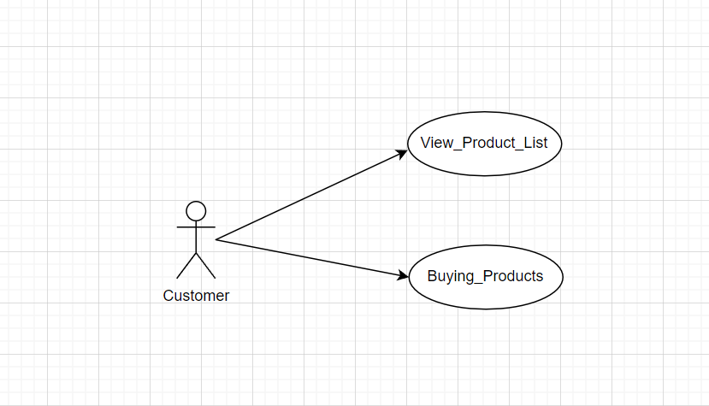

Figure 3.Usecase diagram

4.Use Case Scenario

Table 8. Usecase Scenario Viewing Products

|  |  |
| --- | --- |
| Usecase Scenario 1: Viewing Products | |
| Name | View Products |
| Description | Customers who want to buy products first see the contents of the products available in the Fisherman Business Promotion E-Catalog application. |
| actor | Customer |
| Initial Condition | Customers access the Fisherman Business Promotion E-Catalog Application |
| End state | Consumers see products in the Fishermen's Business Promotion E-Catalogue |
| Main Scenario | * User enters the Fisherman Business Promotion E-Catalog Main page * User presses the get started button * The system will take the user to the product list page to see the products available in the Fisherman Business Promotion E-Catalog Application. |
| Alternative Scenario | - |

Table 9. Usecase Scenario 2 Buying a Product

|  |  |
| --- | --- |
| Usecase Scenario 2 Buying a Product | |
| Name | Buying Products |
| actor | Customer |
| Initial Condition | Customers see products in the Fisherman Business Promotion E-Catalog application |
| End state | Customer Buys Product |
| Main Scenario | * User enters the Fisherman Business Promotion E-Catalog Main page * User presses the get started button * The system will take the user to the product list page to see the products available in the Fisherman Business Promotion E-Catalog Application. * The customer is interested in buying the product and contacting the seller contact that is available. |
| Alternative Scenario | * The customer is disconnected from the internet connection so that they cannot enter the product list page * Customers do not have a quota to contact the seller |

5. Sequence Diagram

Sequence diagram is a diagram used to explain and display interactions between objects in a system in detail.

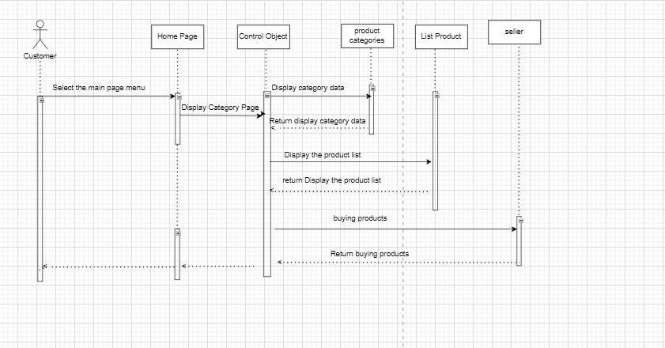

Figure 4. Sequence Diagram

6.Activity diagram

Activity diagram is one type of diagram in process modeling in the world of software engineering and system science that is used to describe the workflow or activity in a particular system or process. Activity diagrams help visualize a series of steps or activities that must be carried out to achieve certain goals in a process or system.

The following is an Activity diagram of the E-Catalog of Fisherman Business Promotion

a.Activity Diagrams of Product List Viewing

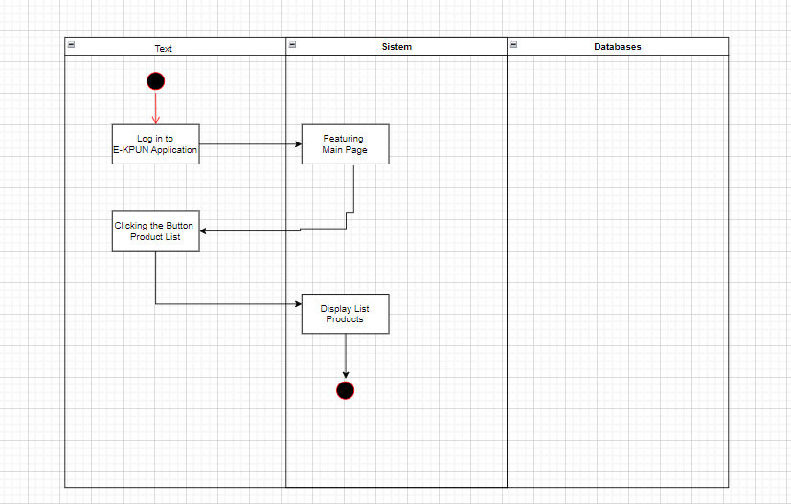

Figure 5.Activity Diagrams of Product List Viewing

b. Activity Diagram of Buying a product

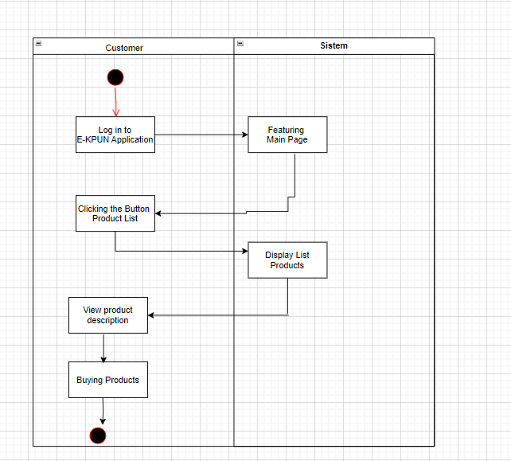

Figure 6.Activity Diagram of Buying a product

## Desain Basisdata

* + - 1. ER diagram

An Entity-Relation Diagram (ER diagram) is a modeling tool used to describe the relationships between entities or objects in a system or database. ER diagrams help identify and visualize entities, attributes, and relationships between entities in a system. The following is the ERD of the PPID Polibatam Application:

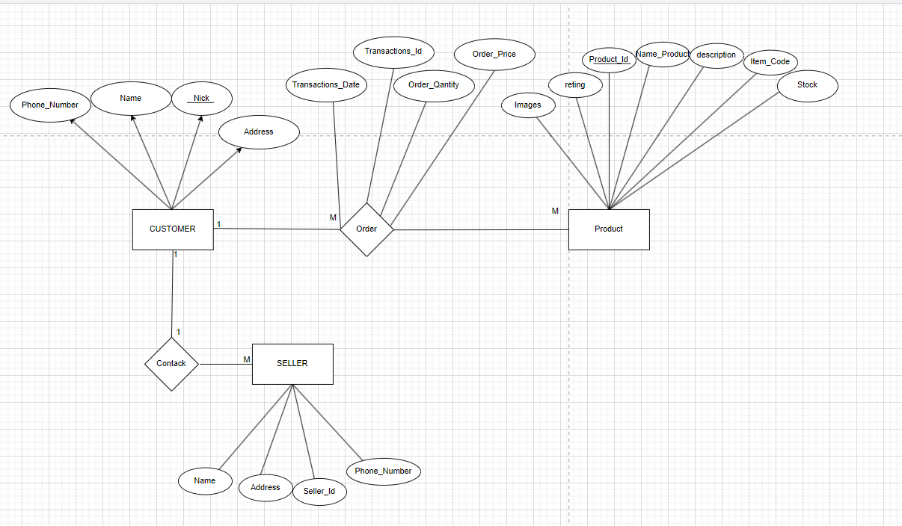

Figure 7.ERD Diagram

Figure 7 above is the Erd of the Fisherman Business Promotion E-Catalog Application which has 3 tables, namely

1.Table Castemer which has 4 attributes

2. Product Table which has 11 attributes

3.Table Seller which has 4 attributes

* + - 1. Skema Relasional

A relational schema is a representation of the database structure or design. It describes how data is stored in a relational database, including what tables exist, what attributes each table has, and how the tables are interconnected through foreign keys. The relational schema provides a high-level view of how data is organized and interacts in a database system. The following is a view of the relational schema of the E-Catalog of Fisherman Business Promotion

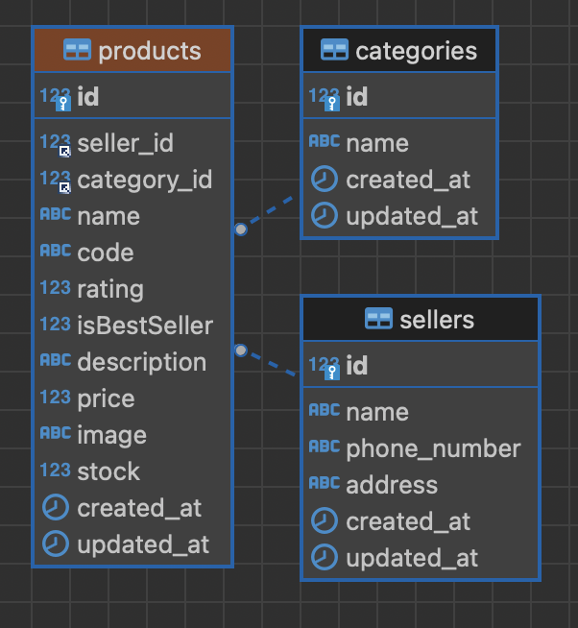

Figure 8. Skema Relasional

## Interface Design

Interface design describes how software communicates with the systems it connects to, and with the humans who use it. The interface design is designed simply so that users can feel comfortable when accessing the application. The following is the interface design for the Fisherman Business Promotion E-Catalog Application

1. Wireframe

|  |  |  |
| --- | --- | --- |
|  |  | A screenshot of a computer |

Figure 8. Fisherman Business Promotion E-Catalog wireframe

# Hasil Implementasi

## Implementasi Aplikasi

The following is the implementation of the Fisherman Business Promotion E-Catalog Application

|  |  |
| --- | --- |
|  |  |

Figure 9.Home & Category Implementation Image

To enter the Fisherman Business Promotion E-Catalog application, customer click the get started button. And on the category menu there are 3 categories that can be ordered by consumers, namely, the Seafood menu, rental and service goods and culinary creations.

|  |  |
| --- | --- |
|  |  |

Figure 10.Product page and product detail images

On the product list page, consumers can select the products they need and those that are available, and on the product details page, consumers can read product descriptions.

|  |
| --- |
|  |

Figure 11.Send Whatshapp

Image of sending a message to the seller

In the figure above, consumers can send a message to the product seller if they are interested in the product.

## Implementasi Basis Data

Database implementation is the process of implementation and execution in an organization or project. The database contains a collection of well-organized data, where the data can be accessed, managed, and updated as needed.

The following are the results of the database implementation of the Fisherman Business Promotion E-Catalog application

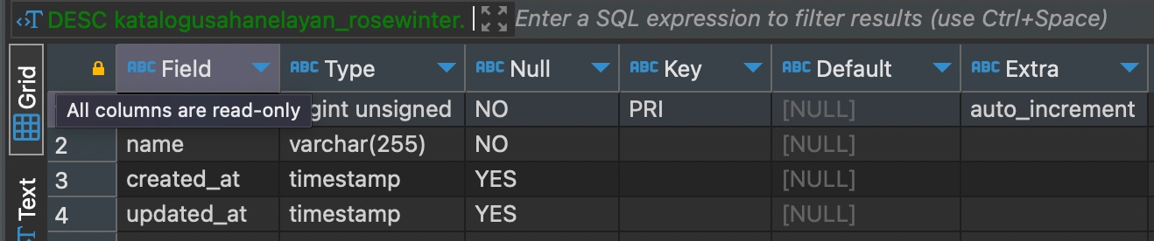

Figure 12.Image of E-KPUN database implementation results

Implementations Coding

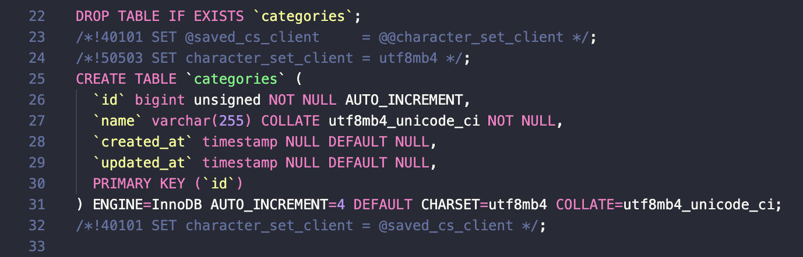

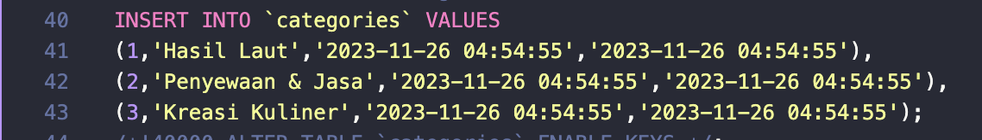

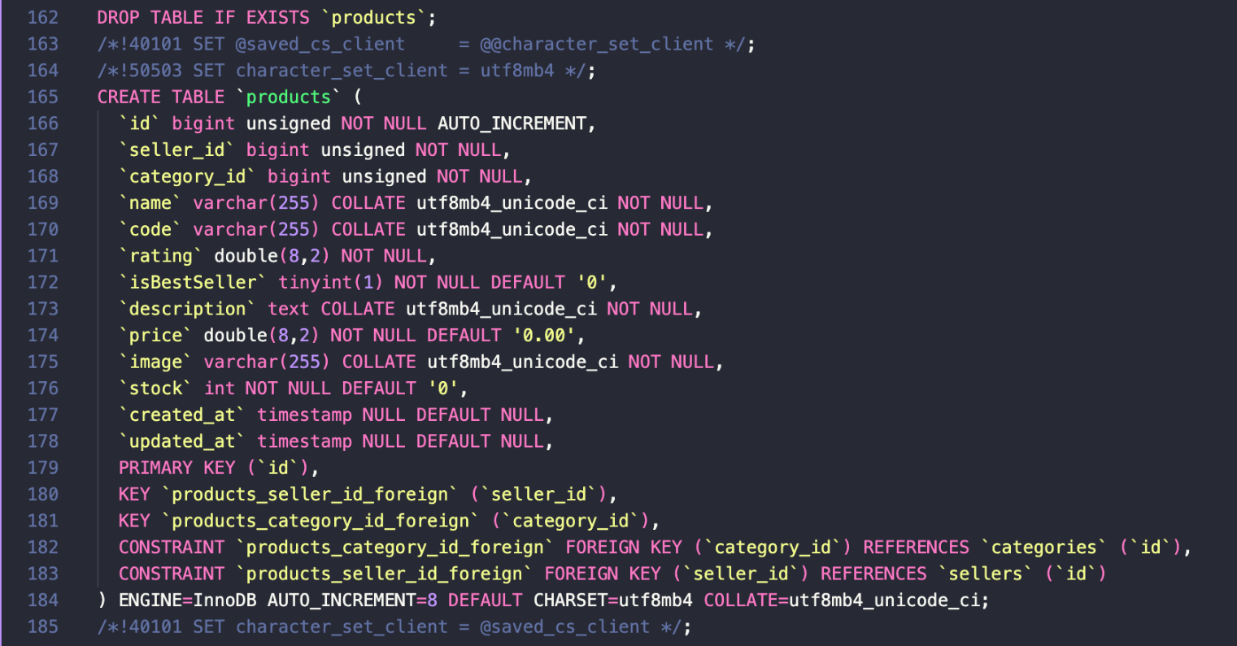

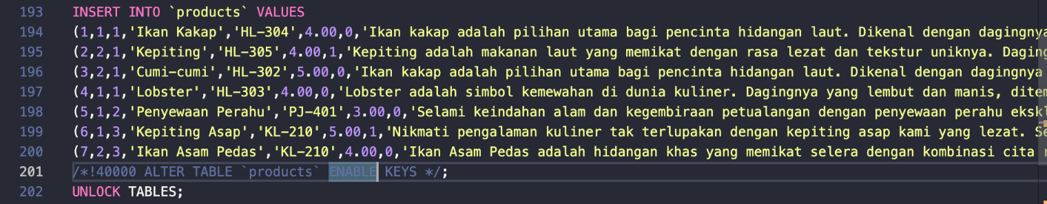

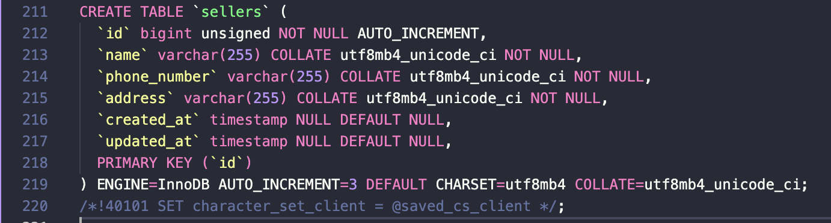



## Pengujian Aplikasi dan Deployment

1. Test Plan

Contains a list of test cases that will be carried out. The tests carried out are functionality tests based on the functionality requirements that have been defined.

Table 10. Testing

|  |  |  |  |  |
| --- | --- | --- | --- | --- |
| Test Case Number | Tester Scenario | Expected Outcom | Testing Results | Conclusion |
| 01 | Log in by Pressing Tobol get started | Customer Dapat Menggunakan Aplikasi E-KPUN tanpa login dan registrasi |  | Valid |
| 02 | Testing category | Customers can use the E-KPUN application without login and registration |  | Valid |
| 03 | Customer Accesses product list to view available products | The system will display a list of products that |  | Valid |
| 04 | Customer accesses menu Description | The system will display product description, product code, and product reting. |  | Valid |
| 05 | Customer buys the product | The system will provide a button that when pressed will be directly connected to the seller's WhatsApp. |  | Valid |

|  |
| --- |
|  |

|  |
| --- |
|  |

# Penutup

## Kesimpulan

## Lesson Learned

*pembelajaran yang didapat dari keseluruhan proses pelaksanaan PBL selama satu semester untuk semua anggota kelompok.*

# LAMPIRAN

Poster

